# CHAPTER 1

# INTRODUCTION

Event management is a process of organizing a professional and focused event, for a particular target audience. It involves visualizing concepts, planning, budgeting, organizing and executing events such as wedding, musical concerts, corporate seminars, exhibitions, birthday celebrations, theme parties, etc. Event Management is a multi-million dollar industry, growing rapidly, with events hosted regularly. Surprisingly, there is no formalized research conducted to access the growth of this industry. The industry includes fields such as the MICE (Meetings, Incentives and Events), exhibitions, conferences and seminars as well as live music and sporting events. On the profession side, event management is a glamorous and exciting profession that demands a lot of hard work and dynamism. The logistics side of the industry is paid less than the sales/sponsorship side, though some may say that these are two different industries.

Event management is the application of [project management](https://en.wikipedia.org/wiki/Project_management) to the creation and development of large scale events. The process of planning and coordinating the event is usually referred to as event planning and which can include budgeting, scheduling, site selection, acquiring necessary [permits,](https://en.wikipedia.org/wiki/License) coordinating transportation and parking, arranging for speakers or entertainers, arranging decor, event security, [catering,](https://en.wikipedia.org/wiki/Catering) coordinating with third party vendors, and emergency plans. The events industry now includes events of all sizes from the [Olympics](https://en.wikipedia.org/wiki/Olympics) down to business breakfast meetings. Many industries, [charitable organizations,](https://en.wikipedia.org/wiki/Charitable_organization) and interest groups hold events in order to market themselves, build business relationships, raise money, or celebrate achievement. An event refers to a social gathering or activity, such as a festival,( for example a musical festival), a ceremony( for example a marriage ) and a party(for example a birthday party).There are mainly 3 types of event management:

1. Corporate Event Management
2. Traditional Event Management
3. Product Launch Event Management
4. Special Event Management

# Event manager

The Event Manager is the person who plans and executes the event. Event managers and their teams are often behind-the-scenes running the event. Event managers may also be involved in more than just the planning and execution of the event, but also brand building, marketing and communication strategy. The event manager is an expert at the creative, technical and logistical elements that help an event succeed. This includes event design, audiovisual production, scriptwriting, logistics, budgeting, negotiation and, of course, client service. It is a multidimensional profession.

## Event Management Process

There are 2 stages of event management process namely, Event planning and Event control.

i. Event Planning: To plan an event we must consider the following areas of an event, viz, feasibility, event proposal.

1. Event Control: To control an event we must look on the following areas logistics, negotiations, costing & cash flow, event manual, I.T, decision making and change, risk management.

## Objectives

The main objective of the Event Management System is to manage the details of Event, Employee, Booking. Venue Package. It manages all the information about Event, Enquiry, Package, Event. The project is totally built at administrative end and thus only the administrator is guaranteed the access. The purpose of the project is to build an application program to reduce the manual work for managing the Event, Employee, Enquiry, Booking. It tracks all the details about the Booking Venue, Package.

## Existing system

This existing system is not providing secure registration and profile management of all the users properly. This system is not providing on-line help. This system doesn’t provide tracking of users activities and their progress. This manual system gives us very less security for saving data and some data may be lost due to mismanagement. This system is not providing

event management through internet. This system is not providing proper events information. The system is giving manual information through the event management executer.

## Feasibility Study

A feasibility study is a high-level capsule version of the entire System analysis and Design Process. The study begins by classifying the problem definition. Feasibility is to determine if it’s worth doing. Once an acceptance problem definition has been generated, the analyst develops a logical model of the system. A search for alternatives is analyzed carefully. There are 3 parts in feasibility study.

**i. Operational Feasibility**

Operational feasibility is the measure of how well a proposed system solves the problems, and takes advantage of the opportunities identified during scope definition and how it satisfies the requirements identified in the requirements analysis phase of system development.The operational feasibility assessment focuses on the degree to which the proposed development projects fits in with the existing business environment and objectives with regard to development schedule, delivery date, [corporate culture](https://en.wikipedia.org/wiki/Corporate_culture) and existing business processes.

**ii. Technical Feasibility**

This involves questions such as whether the technology needed for the system exists, how difficult it will be to build, and whether the firm has enough experience using that technology.

## iii. Economic Feasibility

Establishing the cost-effectiveness of the proposed system i.e. if the benefits do not outweigh the costs then it is not worth going ahead. In the fast paced world today there is a great need of online social networking facilities. Thus the benefits of this project in the current scenario make it economically feasible. The purpose of the economic feasibility assessment is to determine the positive economic benefits to the organization that the proposed system will provide. It includes quantification and identification of all the benefits expected. This assessment typically involves a cost/benefits analysis.

**CHAPTER 2**

**SYSTEM REQUIREMENT SPECIFICATION**

## Hardware Requirements

|  |  |
| --- | --- |
| * + 1. Hardware | **:** Processor Intel dual core and above |
| * + 1. Clock speed | **:** 3.0 GHz + |
| * + 1. RAM size | **:** 512 MB + |
| * + 1. Hard Disk capacity | **:** 400 GB and Above |

* 1. **Software Requirements**

|  |  |
| --- | --- |
| 1. Operating System | **:** Windows XP, Windows 7, Windows 8,Windows 10 |
| 1. Browser | **:** Google chrome latest version |
| 1. Database | **:** MySQL. |
| 1. Documentation | **:** MS-Office |

**CHAPTER 3**

**PROPOSED SYSTEM**

Event Management System is an Online event management software project that serves the functionality of an event manager. The system allows only registered users to login and new users are allowed to register on the application. This is a web application but desktop application of the same application is also available. The project provides most of the basic functionality required for an event. It allows the user to select from a list of event types. Once the user enters an event type eg(Marriage, Stage Show etc), the system then allows the user to select the date and time of event, place and the event equipment’s. All this data is logged in the database and the user is setting up his username and password while registering . The data is then sent to the administrator (website owner) and they may interact with the client as per his requirements and his contact data stored in the database.

## Advantages

i. The system is useful as it calculates an exact cost for all the resources required during the event.

ii. The user gets all the resources at a single place instead of wandering around for these.

iii. This system is effective and saves time and cost of the users.

This study focuses on modeling a representative ‘Event Management System’ for an ‘Event Management Company’. A customer contacts the company for event management. He provides the details of the event and its requirements. He explains its aims, when and where the event will take place, how long it will last, its format (Presentation/Workshop and/or Exhibition etc.), expected number of delegates/guests, equipment and furniture required, whether any delegate pack or promotional material is to be distributed, and other facilities required.

The Event Manager studies the requirements of the event carefully and using the event management system finds the estimated cost and informs the customer about it. The customer may check whether the cost suits the financial provisions of the event. The company can also offer some readymade packages to choose from. If the customer agrees, the event is booked and the advance deposit is taken by the company. According to the requirements of the event, different bookings are made. A strategic schedule is prepared for smooth conduct of the event. The Event Management System helps the manager in different tasks of planning, scheduling and conducting the event. This system provides instant access to event-related information. Thus resources are efficiently and economically utilized. Once the event is conducted successfully, the bills are generated by the system. The system is extensible. New functionalities can be added to the system, whenever it is needed due to changing requirements

# CHAPTER 4

**DESIGN AND ARCHITECTURES**

## Design

Design is the first step in development phase for any techniques and principles for the purpose of defining a device , a process or system in sufficient detail to permit its physical realization. Once the software requirement have been analyzed and specified the software design involves three technical activities-Design, Coding, Implementation, Testing that are required to build and verify the software. The design activities are of main importance in this phase, because in this activities decisions ultimately affecting the success of the software implementation and its ease of maintenance are made. These decision has the final bearing upon reliability and maintainability of the a system. Design is only way to accurately transfer the customers requirements into finished software or system .Design is the place where quality is fostered in development. Software design is the process through which requirements are translated into a representation of software. Software requirement is conducted in two steps. Preliminary design is concerned with the transformation of requirements into data.

## Module Description

The system after careful analysis has been identified to be presented with the following modules.

## User Module

Figure 4.1 User Module

## Administrator Module

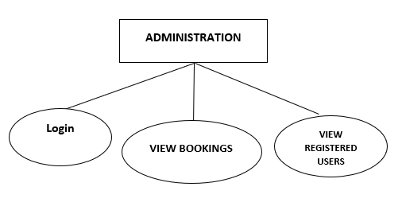

Figure ii Administrator Module

# iii. ARCHITECTURE

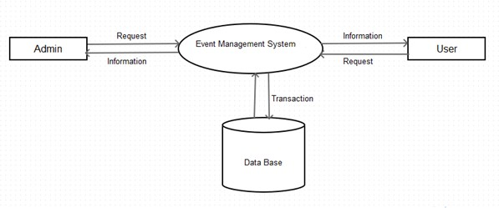

Figure iii. Architecture of Event Management System

## Database Design

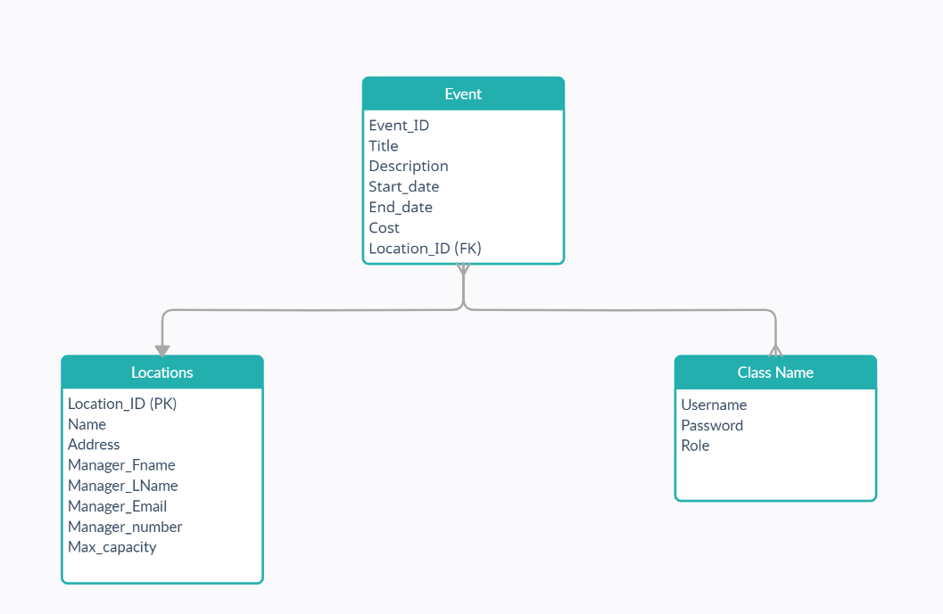

4.3 Database Design

1. **Er-Diagram**

An Entity Relationship Diagram (ERD) is a graphical tool to express the overall structure of a database. It is based on a perception of a real world which consists of a set of basic objects. An entity is a person, place, thong or event of interest to the organization and about which data are captured, stored or processed. The attributes are various kinds of data that describes an entity. An association of several entities in an Entity-Relationship model is called relationship.

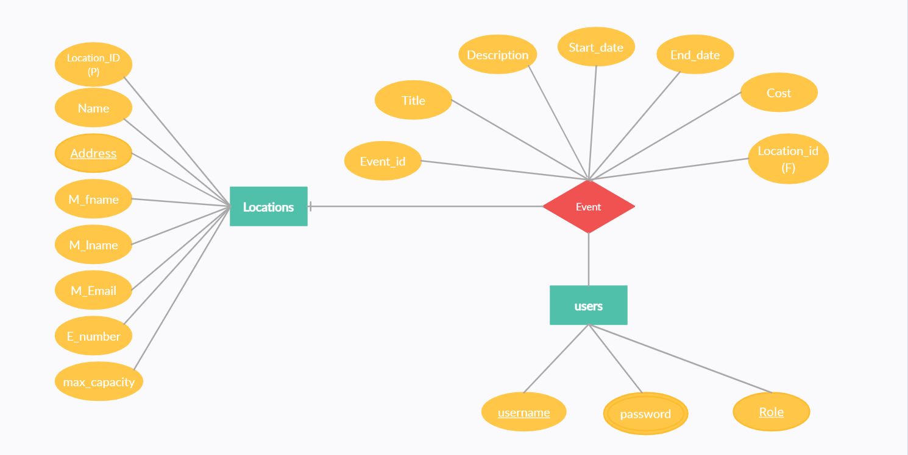

Fig i. E-R Diagram 10

**Tables present in database**

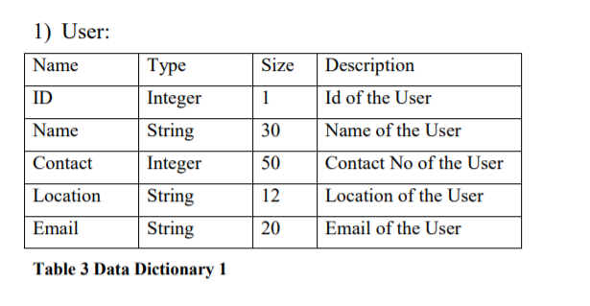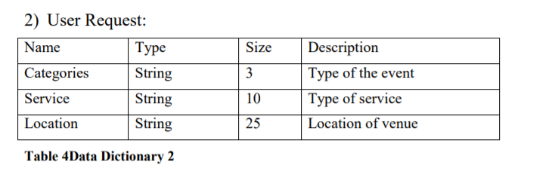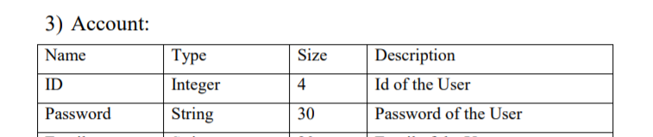

**Table 5Data Dictionary 3**

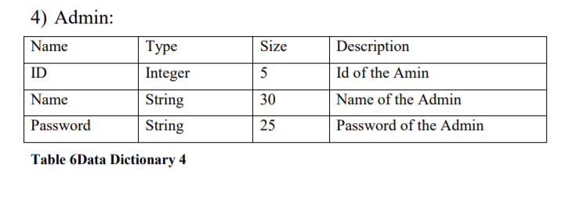11

# CHAPTER 5

# DEVELOPMENT AND CODING

# Technology Description

## Php

PHP is a [server-side scripting](https://en.wikipedia.org/wiki/Server-side_scripting) language designed primarily for [web development](https://en.wikipedia.org/wiki/Web_development) but also used as a [general-purpose programming language.](https://en.wikipedia.org/wiki/General-purpose_programming_language) Originally created by [Rasmus Lerdorf](https://en.wikipedia.org/wiki/Rasmus_Lerdorf) in 1994,the PHP [reference implementation](https://en.wikipedia.org/wiki/Reference_implementation) is now produced by The PHP Development Team. PHP originally stood for personal home page but it now stands for the [recursive acronym](https://en.wikipedia.org/wiki/Recursive_acronym) PHP: Hypertext Preprocessor.

PHP code may be embedded into [HTML](https://en.wikipedia.org/wiki/HTML) or HTML5 code, or it can be used in combination with various [web template systems,](https://en.wikipedia.org/wiki/Web_template_system) [web content management systems](https://en.wikipedia.org/wiki/Web_content_management_system) and [web frameworks](https://en.wikipedia.org/wiki/Web_framework). PHP code is usually processed by a PHP [interpreter](https://en.wikipedia.org/wiki/Interpreter_(computing)) implemented as a [module](https://en.wikipedia.org/wiki/Plugin_(computing)) in the web server or as a [Common Gateway Interface](https://en.wikipedia.org/wiki/Common_Gateway_Interface) (CGI) executable. The web server combines the results of the interpreted and executed PHP code, which may be any type of data, including images, with the generated web page. PHP code may also be executed with a [command-line interface](https://en.wikipedia.org/wiki/Command-line_interface) (CLI) and can be used to implement [standalone](https://en.wikipedia.org/wiki/Computer_software) [graphical applications.](https://en.wikipedia.org/wiki/Graphical_user_interface)

**i . Data Types**

PHP integers in a platform-dependent range, either a 64-bit or 32- bit [signed](https://en.wikipedia.org/wiki/Signed_number_representations) [integer](https://en.wikipedia.org/wiki/Integer_(computer_science)) equivalent to the [C-language long type.](https://en.wikipedia.org/wiki/C_variable_types_and_declarations) Unsigned integers are converted to signed values in certain situations; this behavior is different from that of other programming languages. Integer variables can be assigned using decimal (positive and negative), [octal,](https://en.wikipedia.org/wiki/Octal) [hexadecimal,](https://en.wikipedia.org/wiki/Hexadecimal) and [binary](https://en.wikipedia.org/wiki/Binary_code) notations. [Floating point](https://en.wikipedia.org/wiki/Floating_point) numbers are also stored in a platform-specific range. They can be specified using floating point notation, or two forms of [scientific notation.](https://en.wikipedia.org/wiki/Scientific_notation) PHP has a native [Boolean](https://en.wikipedia.org/wiki/Boolean_datatype) type that is similar to the native Boolean types in [Java](https://en.wikipedia.org/wiki/Java_(programming_language)) and [C++.](https://en.wikipedia.org/wiki/C%2B%2B) Using the Boolean type conversion rules, non-zero values are interpreted as true and zero as false, as in [Perl](https://en.wikipedia.org/wiki/Perl) and C++.The null data type represents a variable that has no value is the only allowed value for this data type. 12

**ii . Functions**

PHP defines a large array of functions in the core language and many are also available in various extensions, these functions are well documented in the online PHP documentation. However, the built-in library has a wide variety of naming conventions and associated inconsistencies, as described under [history](https://en.wikipedia.org/wiki/PHP#ORGANIC) above.

[decision](https://en.wikipedia.org/wiki/Dynamic_dispatch) as to whether or not a function should be defined. There is a function that determines

whether a function with a given name has already been defined. Function calls must use parentheses, with the exception of zero-argument class [constructor](https://en.wikipedia.org/wiki/Constructor_(computer_science)) functions called with the PHP operator new, in which case parentheses are optional.

## iii . Html

Hypertext Markup Language (HTML) is the standard [markup language](https://en.wikipedia.org/wiki/Markup_language) for creating [web](https://en.wikipedia.org/wiki/Web_page) [pages](https://en.wikipedia.org/wiki/Web_page) and [web applications.](https://en.wikipedia.org/wiki/Web_application) With [Cascading Style Sheets](https://en.wikipedia.org/wiki/Cascading_Style_Sheets) (CSS) and [JavaScript](https://en.wikipedia.org/wiki/JavaScript) it forms a triad of cornerstone technologies for the [World Wide Web.](https://en.wikipedia.org/wiki/World_Wide_Web) [Web browsers](https://en.wikipedia.org/wiki/Web_browser) receive HTML documents from a [web server](https://en.wikipedia.org/wiki/Webserver) or from local storage and render them into multimedia web pages. HTML describes the structure of a web page [semantically](https://en.wikipedia.org/wiki/Semantic) and originally included cues for the appearance of the document.[HTML elements](https://en.wikipedia.org/wiki/HTML_element) are the building blocks of HTML pages.

## iv . MySQL

MySQL is an [open-source](https://en.wikipedia.org/wiki/Open-source) [relational database management system](https://en.wikipedia.org/wiki/Relational_database_management_system) (RDBMS). Its name is a combination of "My", the name of co-founder daughter, and "[SQL](https://en.wikipedia.org/wiki/SQL)", the abbreviation for [Structured Query Language.](https://en.wikipedia.org/wiki/Structured_Query_Language) The MySQL development project has made its [source code](https://en.wikipedia.org/wiki/Source_code) available under the terms of the [GNU General Public License,](https://en.wikipedia.org/wiki/GNU_General_Public_License) as well as under a variety of [proprietary](https://en.wikipedia.org/wiki/Proprietary_software) agreements. MySQL was owned and sponsored by a single [for-profit](https://en.wikipedia.org/wiki/Business) firm, the [Swedish](https://en.wikipedia.org/wiki/Sweden) company [MySQL AB,](https://en.wikipedia.org/wiki/MySQL_AB) now owned by [Oracle Corporation.](https://en.wikipedia.org/wiki/Oracle_Corporation)

13

# CHAPTER 6

**TESTING AND IMPLEMENTATION**

## 6 The Testing Spectrum

The term implementation has different meanings ranging from the conversation of a basic application to a complete replacement of a computer system. The procedures however, are virtually the same. Implementation includes all those activities that take place to convert from old system to new. The new system may be totally new replacing an existing manual or automated system or it may be major modification to an existing system. The method of implementation and time scale to be adopted is found out initially. Proper implementation is essential to provide a reliable system to meet organization requirement.

## Unit Testing

In [computer programming,](https://en.wikipedia.org/wiki/Computer_programming) unit testing is a [software testing](https://en.wikipedia.org/wiki/Software_testing) method by which individual units of [source code](https://en.wikipedia.org/wiki/Source_code), sets of one or more computer program modules together with associated control data, usage procedures, and operating procedures, are tested to determine whether they are fit for use. Intuitively, one can view a unit as the smallest testable part of an application. In [procedural](https://en.wikipedia.org/wiki/Procedural_programming) [programming,](https://en.wikipedia.org/wiki/Procedural_programming) a unit could be an entire module, but it is more commonly an individual function or procedure. In [object-oriented programming,](https://en.wikipedia.org/wiki/Object-oriented_programming) a unit is often an entire interface, such as a class, but could be an individual method. Unit tests are short code fragments created by programmers or occasionally by [white box testers](https://en.wikipedia.org/wiki/White-box_testing) during the development process. It forms the basis for component testing. Ideally, each [test case](https://en.wikipedia.org/wiki/Test_case) is independent from the others. Substitutes such as [method stubs,](https://en.wikipedia.org/wiki/Method_stub) [mock objects,](https://en.wikipedia.org/wiki/Mock_object) [fakes,](https://en.wikipedia.org/wiki/Mock_object#Mocks.2C_fakes.2C_and_stubs) and [test harnesses](https://en.wikipedia.org/wiki/Test_harness) can be used to assist testing a module in isolation. Unit tests are typically written and run by [software developers](https://en.wikipedia.org/wiki/Software_developer) to ensure that code meets its design and behaves as intended.

## Benefits

The goal of unit testing is to isolate each part of the program and show that the individual parts are correct. A unit test provides a strict, written [contract](https://en.wikipedia.org/wiki/Design_by_Contract) that the piece of code must satisfy. As a result, it affords several benefits.

## i. Find problems early

Unit testing finds problems early in the [development cycle.](https://en.wikipedia.org/wiki/Development_cycle) In [test-driven](https://en.wikipedia.org/wiki/Test-driven_development) [development](https://en.wikipedia.org/wiki/Test-driven_development) (TDD), which is frequently used in both [extreme programming](https://en.wikipedia.org/wiki/Extreme_programming) and [scrum,](https://en.wikipedia.org/wiki/Scrum_(software_development)) unit tests are created before the code itself is written. When the tests pass, that code is considered complete. The same unit tests are run against that function frequently as the larger code base is developed either as the code is changed or via an automated process with the build. If the unit tests fail, it is considered to be a bug either in the changed code or the tests themselves. The unit tests then allow the location of the fault or failure to be easily traced. Since the unit tests alert the development team of the problem before handing the code off to testers or clients, it is still early in the development process.

**6.2 Facilitates Change**

Unit testing allows the programmer to [refactor](https://en.wikipedia.org/wiki/Refactoring) code or upgrade system libraries at a later date, and make sure the module still works correctly (e.g., in [regression testing](https://en.wikipedia.org/wiki/Regression_testing)). The procedure is to write test cases for all [functions](https://en.wikipedia.org/wiki/Subroutine) and [methods](https://en.wikipedia.org/wiki/Method_(computer_science)) so that whenever a change causes a fault, it can be quickly identified. Unit tests detect changes which may break a [design contract](https://en.wikipedia.org/wiki/Design_by_contract).

## i. Simplifies Integration

Unit testing may reduce uncertainty in the units themselves and can be used in a [bottom-](https://en.wikipedia.org/wiki/Top-down_and_bottom-up_design) [up](https://en.wikipedia.org/wiki/Top-down_and_bottom-up_design) testing style approach. By testing the parts of a program first and then testing the sum of its parts, [integration testing](https://en.wikipedia.org/wiki/Integration_testing) becomes much easier.

## ii .Documentation

Unit testing provides a sort of living documentation of the system. Developers looking to learn what functionality is provided by a unit, and how to use it, can look at the unit tests to gain a basic understanding of the unit's interface ([API](https://en.wikipedia.org/wiki/Application_programming_interface)).Unit [test cases](https://en.wikipedia.org/wiki/Test_case) embody characteristics that are critical to the success of the unit. These characteristics can indicate appropriate/inappropriate use of a unit as well as negative behaviors that are to be trapped by the unit. A unit test case, in and of itself, documents these critical characteristics, although many software development environments do not rely solely upon code to document the product in development.

## 6.3 Integration Testing

Integration testing (sometimes called integration and testing, abbreviated I&T) is the phase in [software testing](https://en.wikipedia.org/wiki/Software_testing) in which individual software modules are combined and tested as a group. It occurs after [unit testing](https://en.wikipedia.org/wiki/Unit_testing) and before [validation testing.](https://en.wikipedia.org/wiki/Verification_and_validation_(software)) Integration testing takes as its input [modules](https://en.wikipedia.org/wiki/Module_(programming)) that have been unit tested, groups them in larger aggregates, applies tests defined in an integration [test plan](https://en.wikipedia.org/wiki/Test_plan) to those aggregates, and delivers as its output the integrated system ready for [system testing.](https://en.wikipedia.org/wiki/System_testing)

## i . Purpose

The purpose of integration testing is to verify functional, performance, and reliability [requirements](https://en.wikipedia.org/wiki/Requirement) placed on major design items. These "design items", i.e., assemblages (or groups of units), are exercised through their interfaces using [black-box](https://en.wikipedia.org/wiki/Black-box_testing) [testing,](https://en.wikipedia.org/wiki/Black-box_testing) success and error cases being simulated via appropriate parameter and data inputs. Simulated usage of shared data areas and [inter-process communication](https://en.wikipedia.org/wiki/Inter-process_communication) is tested and individual [subsystems](https://en.wikipedia.org/wiki/Subsystem) are exercised through their input interface. [Test cases](https://en.wikipedia.org/wiki/Test_case) are constructed to test whether all the components within assemblages interact correctly, for example across procedure calls or process activations, and this is done after testing individual modules, i.e., unit testing. The overall idea is a "building block" approach, in which verified assemblages are added to a verified base which is then used to support the integration testing of further assemblages. Software integration testing is performed according to the software development life cycle (SDLC) after module and functional tests. The cross-dependencies for software integration testing are: schedule for integration testing, strategy and selection of the tools used for integration, define the cyclomatical complexity of the software and software architecture, reusability of modules and life- cycle and versioning management. Some different types of integration testing are big- bang, [top-down, and bottom-up,](https://en.wikipedia.org/wiki/Top-down_and_bottom-up_design) mixed (sandwich) and risky-hardest. Other Integration Patterns[[2]](https://en.wikipedia.org/wiki/Integration_testing#cite_note-2) are: collaboration integration, backbone integration, layer integration, client- server integration, distributed services integration and high-frequency integration.

## ii . Big Bang

In the big-bang approach, most of the developed modules are coupled together to form a complete software system or major part of the system and then used for integrationtesting. This method is very effective for saving time in the integration testing process. However, if the test cases and their results are not recorded properly, the entire integration process will be more complicated and may prevent the testing team from achieving the goal of integration testing.A type of big-bang integration testing is called "usage model testing" which can be used in both software and hardware integration testing. The basis behind this type of integration testing is to run user-like workloads in integrated user-like environments. In doing the testing in this manner, the environment is proofed, while the individual components are proofed indirectly through their use. Usage Model testing takes an optimistic approach to testing, because it expects to have few problems with the individual components. The strategy relies heavily on the component developers to do the isolated unit testing for their product. The goal of the strategy is to avoid redoing the testing done by the developers, and instead flesh-out problems caused by the interaction of the components in the environment. For integration testing, Usage Model testing can be more efficient and provides better test coverage than traditional focused functional integration testing. To be more efficient and accurate, care must be used in defining the user-like workloads for creating realistic scenarios in exercising the environment. This gives confidence that the integrated environment will work as expected for the target customers.

## 6.3. Top-down And Bottom-up

Bottom-up testing is an approach to integrated testing where the lowest level components are tested first, then used to facilitate the testing of higher level components. The process is repeated until the component at the top of the hierarchy is tested. All the bottom or low- level modules, procedures or functions are integrated and then tested. After the integration testing of lower level integrated modules, the next level of modules will be formed and can be used for integration testing. This approach is helpful only when all or most of the modules of the same development level are ready. This method also helps to determine the levels of software developed and makes it easier to report testing progress in the form of a percentage. Top-down testing is an approach to integrated testing where the top integrated modules are tested and the branch of the module is tested step by step until the end of the related module. Sandwich testing is an approach to combine top down testing with bottom up testing.

## i . Software Verification and Validation

In [software project management](https://en.wikipedia.org/wiki/Software_project_management), [software testing](https://en.wikipedia.org/wiki/Software_testing), and [software engineering,](https://en.wikipedia.org/wiki/Software_engineering) verification and validation (V&V) is the process of checking that a software system meets specifications and that it fulfills its intended purpose. It may also be referred to as [software quality control](https://en.wikipedia.org/wiki/Software_quality_control). It is normally the responsibility of [software testers](https://en.wikipedia.org/wiki/Software_testing) as part of the [software development lifecycle.](https://en.wikipedia.org/wiki/Software_development_process) Validation checks that the product design satisfies or fits the intended use (high-level checking), i.e., the software meets the user requirements. This is done through [dynamic testing](https://en.wikipedia.org/wiki/Dynamic_testing) and other forms of review. Verification and validation are not the same thing, although they are often confused. [Boehm](https://en.wikipedia.org/wiki/Barry_Boehm) succinctly expressed the difference between

* Validation: Are we building the right product?

* Verification: Are we building the product right?

ii . Software Verification: The process of evaluating software to determine whether the products of a given development phase satisfy the conditions imposed at the start of that phase.

iii. Software Validation: The process of evaluating software during or at the end of the development process to determine whether it satisfies specified requirements.

In other words, software verification is ensuring that the product has been built according to the requirements and design specifications, while software validation ensures that the product meets the user's needs, and that the specifications were correct in the first place. Software verification ensures that "you built it right". Software validation ensures that "you built the right thing". Software validation confirms that the product, as provided, will fulfill its intended use.

From testing perspective:

i. Fault – wrong or missing function in the code.

ii. Failure – the manifestation of a fault during execution.

iii. Malfunction – according to its specification the system does not meet its specified functionality.

Both verification and validation are related to the concepts of [quality](https://en.wikipedia.org/wiki/Quality_(business)) and of [software quality](https://en.wikipedia.org/wiki/Software_quality_assurance) [assurance.](https://en.wikipedia.org/wiki/Software_quality_assurance) By themselves, verification and validation do not guarantee software quality; planning, [traceability,](https://en.wikipedia.org/wiki/Traceability) configuration management and other aspects of software engineering are required. Within the [modeling and simulation](https://en.wikipedia.org/wiki/Modeling_and_simulation) (M&S) community, the definitions of verification, validation and accreditation are similar:

i. M&S Verification is the process of determining that a [computer model,](https://en.wikipedia.org/wiki/Computer_model) simulation, or federation of models and simulations implementations and their associated data accurately represent the developer's conceptual description and specifications.

ii. M&S Validation is the process of determining the degree to which a model, simulation, or federation of models and simulations, and their associated data are accurate representations of the real world from the perspective of the intended use(s).

iii. [Accreditation](https://en.wikipedia.org/wiki/Accreditation) is the formal certification that a model or simulation is acceptable to be used for a specific purpose.

The definition of M&S validation focuses on the accuracy with which the M&S represents the real-world intended use(s). Determining the degree of M&S accuracy is required because all M&S are approximations of reality, and it is usually critical to determine if the degree of approximation is acceptable for the intended use(s). This stands in contrast to software validation.

**6.4 Classification of Methods**

In [mission-critical](https://en.wikipedia.org/wiki/Mission-critical) software systems, where flawless performance is absolutely necessary, [formal methods](https://en.wikipedia.org/wiki/Formal_methods) may be used to ensure the correct operation of a system. However, often for non-mission-critical software systems, formal methods prove to be very costly and an alternative method of software V&V must be sought out. In such cases, [syntactic methods](https://en.wikipedia.org/wiki/Syntactic_methods) are often used.

**i. Test Cases**

A test case is a tool used in the process. Test cases may be prepared for software verification and software validation to determine if the product was built according to the requirements of the user. Other methods, such as reviews, may be used early in the life cycle to provide for software validation.

**Levels**

i. [Unit testing.](https://en.wikipedia.org/wiki/Unit_testing) White-box testing is done during unit testing to ensure that the code is working as intended, before any integration happens with previously tested code. White- box testing during unit testing catches any defects early on and aids in any defects that happen later on after the code is integrated with the rest of the application and therefore prevents any type of errors later on.

ii. [Integration testing.](https://en.wikipedia.org/wiki/Integration_testing) White-box testing at this level are written to test the interactions of each interface with each other. The Unit level testing made sure that each code was tested and working accordingly in an isolated environment and integration examines the correctness of the behaviour in an open environment through the use of white-box testing for any interactions of interfaces that are known to the programmer.

iii. [Regression testing.](https://en.wikipedia.org/wiki/Regression_testing) White-box testing during regression testing is the use of recycled white-box test cases at the unit and integration testing levels.

**6.5 Basic Procedures**

White-box testing's basic procedures involves the tester having a deep level of understanding of the source code being tested. The programmer must have a deep understanding of the application to know what kinds of test cases to create so that every visible path is exercised for testing. Once the source code is understood then the source code can be analyzed for test cases to be created.

These are the three basic steps that white-box testing takes in order to create test cases:

i. Input involves different types of requirements, functional specifications, detailed designing of documents, proper source code, security specifications. This is the preparation stage of white-box testing to layout all of the basic informationii. Processing involves performing risk analysis to guide whole testing process, proper test plan, execute test cases and communicate results. This is the phase of building test cases to make sure they thoroughly test the application the given results are recorded accordingly.

iii. Output involves preparing final report that encompasses all of the above preparations and results.

## iv. Advantages

White-box testing is one of the two biggest testing methodologies used today. It has several major advantages:

i. Side effects of having the knowledge of the source code is beneficial to thorough testing.

ii. Optimization of code by revealing hidden errors and being able to remove these possible defects.

iii. Gives the programmer introspection because developers carefully describe any new implementation.

iv. Provides traceability of tests from the source, allowing future changes to the software to be easily captured in changes to the tests.

v. White box tests are easy to automate.

vi. White box testing gives clear, engineering-based, rules for when to stop testing.

## v. Disadvantages

Although white-box testing has great advantages, it is not perfect and contains some disadvantages:

i. White-box testing brings complexity to testing because the tester must have knowledge of the program, including being a programmer. White-box testing requires a programmer with a high level of knowledge due to the complexity of the level of testing that needs to be done.

ii. On some occasions, it is not realistic to be able to test every single existing condition of the application and some conditions will be untested.

iii.The tests focus on the software as it exists, and missing functionality may not be discovered.

**6.6 System Testing**

System testing of software or hardware is testing conducted on a complete, integrated system to evaluate the system's compliance with its specified [requirements](https://en.wikipedia.org/wiki/Requirements). System testing falls within the scope of [black-box testing,](https://en.wikipedia.org/wiki/Black-box_testing) and as such, should require no knowledge of the inner design of the code or logic. As a rule, system testing takes, as its input, all of the "integrated" software components that have passed [integration testing](https://en.wikipedia.org/wiki/Integration_testing) and also the software system itself integrated with any applicable hardware system(s). The purpose of integration testing is to detect any inconsistencies between the software units that are integrated together (called assemblages) or between any of the assemblages and the hardware. System testing is a more limited type of testing; it seeks to detect defects both within the "inter-assemblages" and also within the system as a whole.

**6.7 Testing the Whole System**

System testing is performed on the entire system in the context of a [Functional](https://en.wikipedia.org/wiki/Functional_requirements) [Requirement](https://en.wikipedia.org/wiki/Functional_requirements) Specification(s) (FRS) and/or a [System Requirement](https://en.wikipedia.org/wiki/Requirements_analysis) Specification (SRS). System testing tests not only the design, but also the behavior and even the believed expectations of the customer. It is also intended to test up to and beyond the bounds defined in the software/hardware requirements specification(s).

**CHAPTER-08**

# SCREENSHOTS

# 

# Fig 8.1 : describe the contents present in the Database

# Fig 8.2 Describe the contents present in the Database

# 

# FIG 8.3 Describes the Tables present in Database

# 

# Fig 8.4 : Contact us page Present in Website

# 

# Fig 8.5 Meeting page along with Description

# 

# Fig 8.5 Fashion page along with Description

# 

# Fig 8.6 Wedding page along with Description

# 

# Fig 8.7 Birthday page along with Description

# 

# Fig 8.8 Event Portal

# 

# Fig 8.9 Login Page in the website

# Fig 8.10 Home page of Event Management System

# 

# Fig 8.11 Detailed information of Locations present in the Website

# 

# Fig 8.12 Past Image Present in the website

# 

# Fig 8.13 Describe the contents present in the Database

**CONCLUSION**

Our project is only a humble venture to satisfy the needs to manage their project work. Several user friendly coding have also adopted. This package shall prove to be a powerful package in satisfy all requirements of the user. The objective of software planning is to provide a frame work that enable the manager to make reasonable estimate made within a limited time frame at the beginning of the software project and should be update regularly as the project regularly.

At the end it is concluded that we have made effort on following points, A description of background and context of the project and its relation to work already done in the area, Made statement of the aims and objectives of the project ,The description of the purpose, scope and applicability , We define the project on which we are working in project ,We describe the requirement specifications of the system and actions that can be done on these things ,We designed user interface and security issues related to system , Finally the system is implemented and tested according to the test cases.

**REFERENCES**

[1] Allen, J. "Event planning: the ultimate guide to successful meetings, corporate events, fund-raising galas, conferences, conventions, incentives and other special events". 2nd ed. Mississauga, ON.: Wiley. (2002)

[2] Berridge, G. "Events design and experience". Oxford: Butterworth-Heinemann.(2006)

Bowdin, G. A. J. " Events management" . 3rd ed. London: Butterworth-Heinemann. (2010)

[3] Davidson, R. and Rogers, T. "Marketing destinations and venues for conferences" , conventions and business events: a convention and event perspective. Oxford: Butterworth-Heinemann. (2006)

[4] Davidson, R. and Rogers, T. "Marketing destinations and venues for conferences" , conventions and business events: a convention and event perspective. Oxford: Butterworth-Heinemann. (2015)